Meteb Almadi 200304

https://github.com/metebalmadi/midterm2.git

Q1:



Q2:

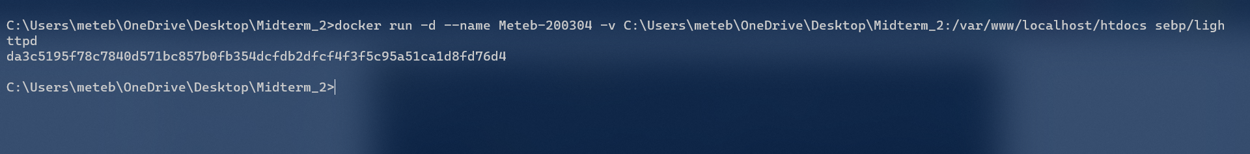

Q3:

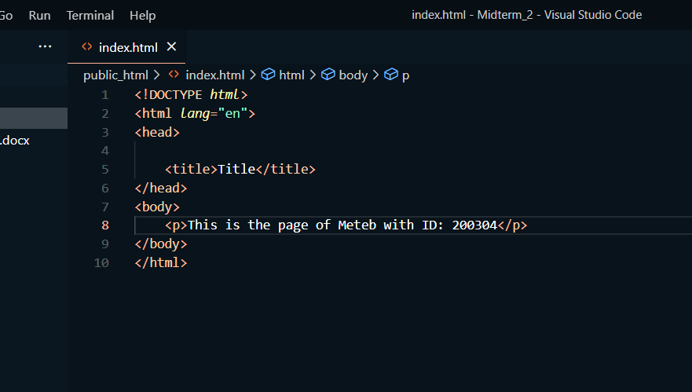

Q4:



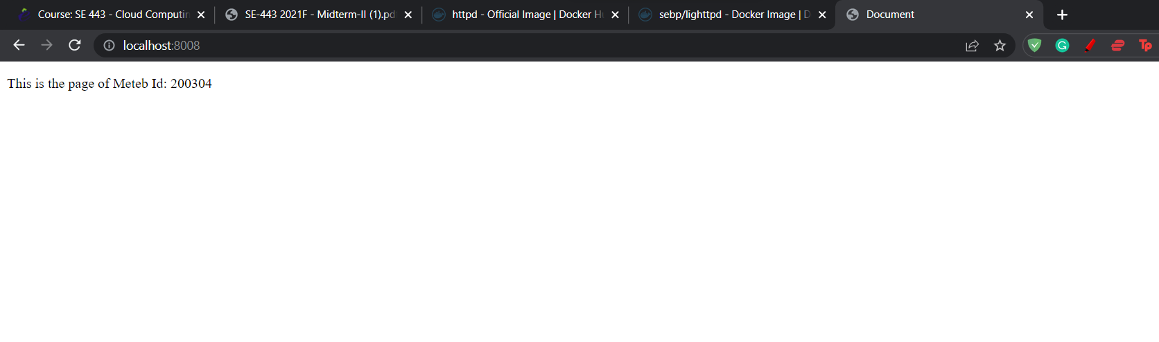

**After alter**

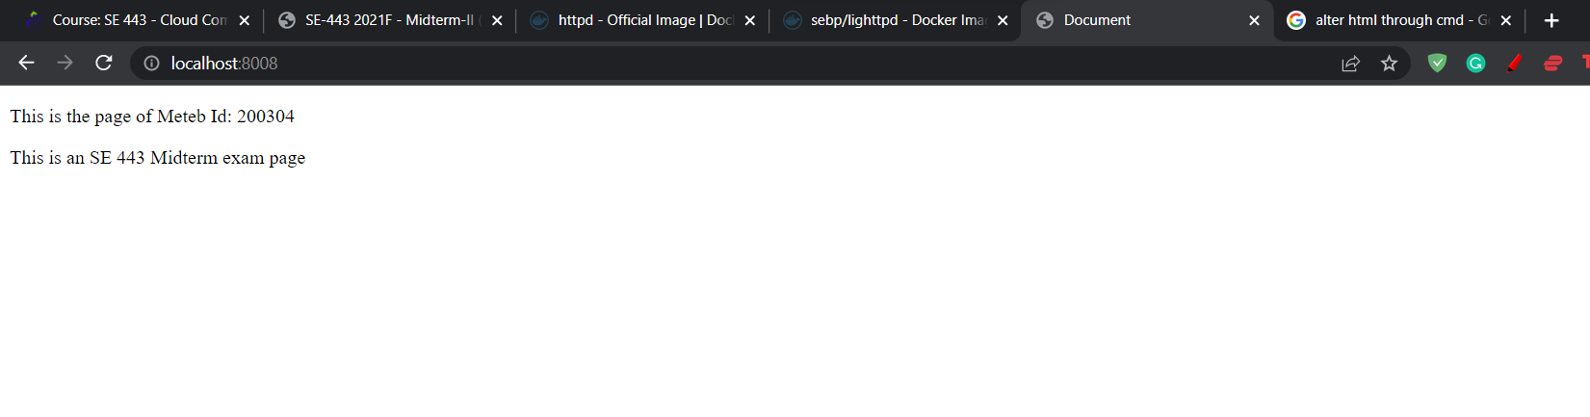

Q5:

a)

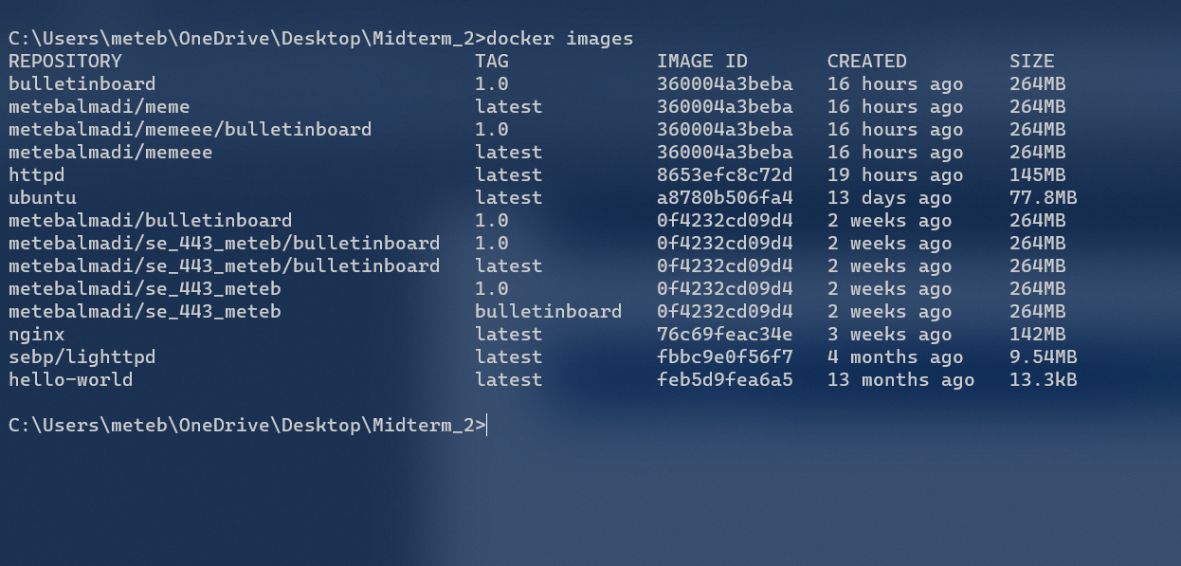

b)

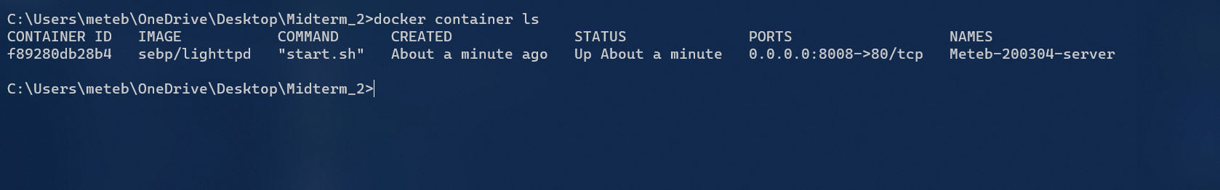

c)

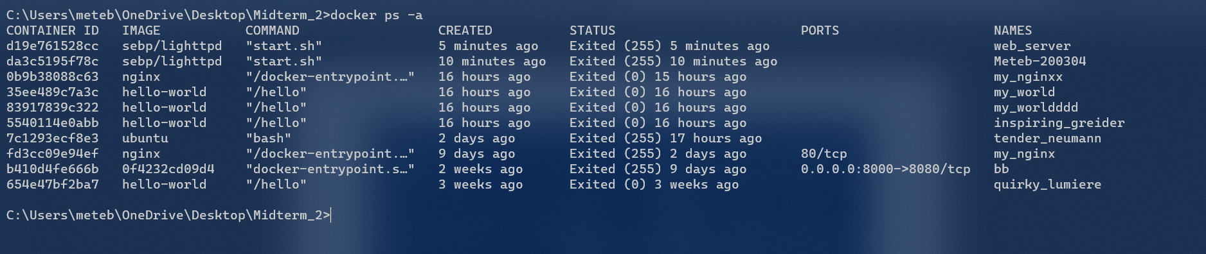

Q6:



Q7:

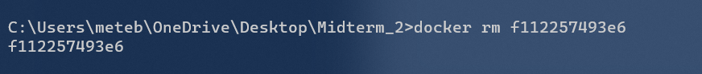

Q8:

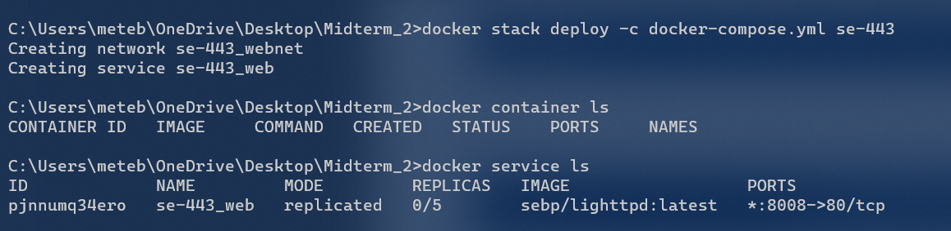

Q9:

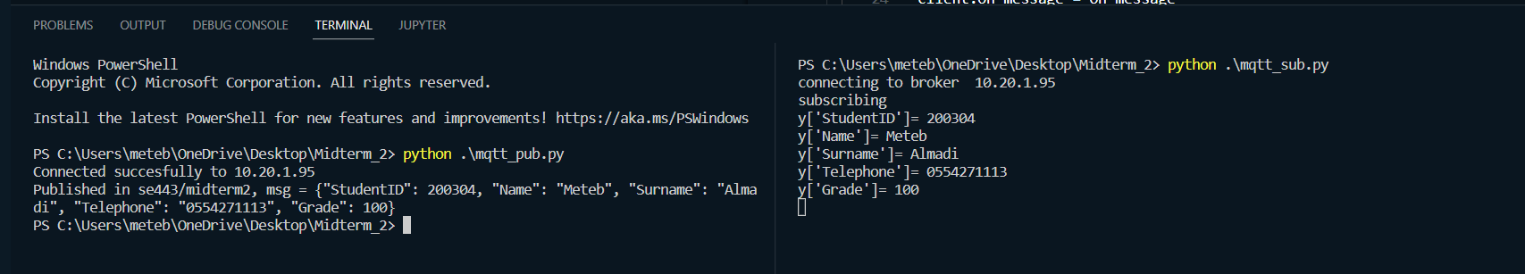

Publisher:

import paho.mqtt.client as mqtt

import json

*# broker_address="localhost"*

broker_address = "10.20.1.95"

*# This is the Publisher*

client = mqtt.Client()

topic = "se443/midterm2"

x =  { "StudentID":200304, "Name":"Meteb", "Surname":"Almadi", "Telephone":"0554271113", "Grade": 100}

y = json.dumps(x)

message = y

*# message = "Hello from George V's Python client..."*

if (client.connect(broker_address,1883,60) ==0):

    print ("Connected succesfully to "+broker_address)

client.publish(topic, message)

print ("Published in "+topic+", msg = "+message)

client.disconnect();

Subscriber:

import time

import paho.mqtt.client as paho

import json

*# broker = "localhost"*

broker = "10.20.1.95"

*#broker="iot.eclipse.org"*

*#define callback*

def on_message(client, userdata, message):

    time.sleep(1)

    y = json.loads(str(message.payload.decode("utf-8")))

    print("y['StudentID']=", y["StudentID"])

    print("y['Name']=", y["Name"])

    print("y['Surname']=", y["Surname"])

    print("y['Telephone']=", y["Telephone"])

    print("y['Grade']=", y["Grade"])

client= paho.Client()

client.on_message = on_message

print("connecting to broker ",broker)

client.connect(broker)*#connect*

client.loop_start() *#start loop to process received messages*

print("subscribing ")

client.subscribe("se443/midterm2")*#subscribe*

while(True):

    client.on_message=on_message